|  |  |
| --- | --- |
| **Exp No: 5**  **Date: 23.2.25** | **Servlet program to demonstrate difference between HttpGet and Post method** |

**AIM:**

TO demonstrate difference between HttpGet and Post method using servlet.

**PROGRAM:**

**SignUpPost.jsp**

package com.signupproject.controller;

import java.io.IOException;

import java.io.PrintWriter;

import javax.servlet.ServletException;

import javax.servlet.annotation.WebServlet;

import javax.servlet.http.HttpServlet;

import javax.servlet.http.HttpServletRequest;

import javax.servlet.http.HttpServletResponse;

/**

* Servlet implementation class SignUpServlet

*/

@WebServlet("/SignUpServlet")

public class SignUpServlet extends HttpServlet {

private static final long serialVersionUID = 1L;

/**

* Default constructor.

*/

public SignUpServlet() {

// TODO Auto-generated constructor stub

}

/**

* @see HttpServlet#doGet(HttpServletRequest request, HttpServletResponse response)

*/

protected void doGet(HttpServletRequest request, HttpServletResponse response) throws ServletException, IOException {

// TODO Auto-generated method stub

response.getWriter().append("Served at: ").append(request.getContextPath());

}

/**

* @see HttpServlet#doPost(HttpServletRequest request, HttpServletResponse response)

*/

protected void doPost(HttpServletRequest request, HttpServletResponse response) throws ServletException, IOException {

response.setContentType("text/html");

PrintWriter writer = response.getWriter();

String name = request.getParameter("name");

String age = request.getParameter("age");

String gender = request.getParameter("gender");

String address = request.getParameter("address");

writer.println("<!DOCTYPE html>");

writer.println("<html>");

writer.println("<head>");

writer.println("<title>User Details</title>");

writer.println("</head>");

writer.println("<body>");

writer.println("<h2>User Details:</h2>");

writer.println("<p>Name: " + name + "</p>");

writer.println("<p>Age: " + age + "</p>");

writer.println("<p>Gender: " + gender + "</p>");

writer.println("<p>Address: " + address + "</p>");

writer.println("</body>");

writer.println("</html>");

}

}

**SignUpPostDetails.java**

package com.sricharan_170.servlet;  
  
import java.io.IOException;  
import java.io.PrintWriter;  
  
import javax.servlet.ServletException;  
import javax.servlet.annotation.WebServlet;  
import javax.servlet.http.HttpServlet;  
import javax.servlet.http.HttpServletRequest;  
import javax.servlet.http.HttpServletResponse;  
  
/**  
 * Servlet implementation class SignUpPostDetails  
 */  
@WebServlet("/SignUpPostDetails/")  
public class SignUpPostDetails extends HttpServlet {  
private static final long serialVersionUID = 1L;  
         
    /**  
     * @see HttpServlet#HttpServlet()  
     */  
    public SignUpPostDetails() {  
        super();  
        // TODO Auto-generated constructor stub  
    }  
  
/**  
* @see HttpServlet#doGet(HttpServletRequest request, HttpServletResponse response)  
*/  
protected void doGet(HttpServletRequest request, HttpServletResponse response) throws ServletException, IOException {  
// TODO Auto-generated method stub  
response.getWriter().append("Served at: ").append(request.getContextPath());  
}  
  
/**  
* @see HttpServlet#doPost(HttpServletRequest request, HttpServletResponse response)  
*/  
protected void doPost(HttpServletRequest request, HttpServletResponse response) throws ServletException, IOException {  
// TODO Auto-generated method stub  
String f_name=request.getParameter("fname");  
String l_name=request.getParameter("lname");  
String dob_v=request.getParameter("dob");  
String gen=request.getParameter("gender");  
String add=request.getParameter("address");  
  
PrintWriter p = response.getWriter();  
  
p.println("First Name: "+f_name+"<br>");  
p.println("Last Name: "+l_name+"<br>");  
p.print("Age: "+dob_v+"<br>");  
p.print("Gender: "+gen+"<br>");  
p.print("Address: "+add+"<br>");  
}  
  
}

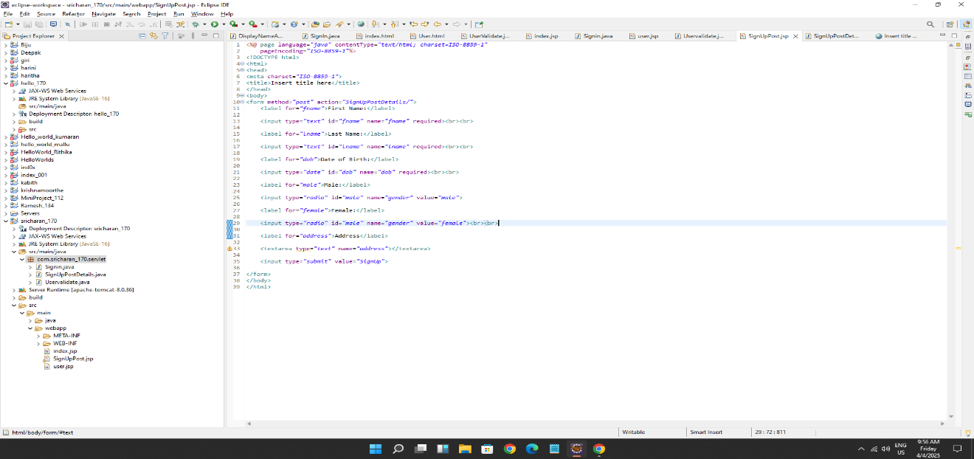

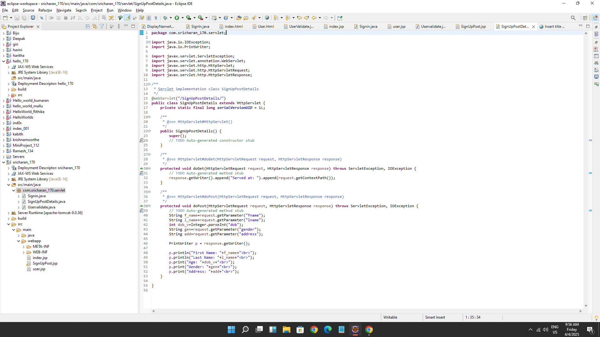

**OUTPUT:**

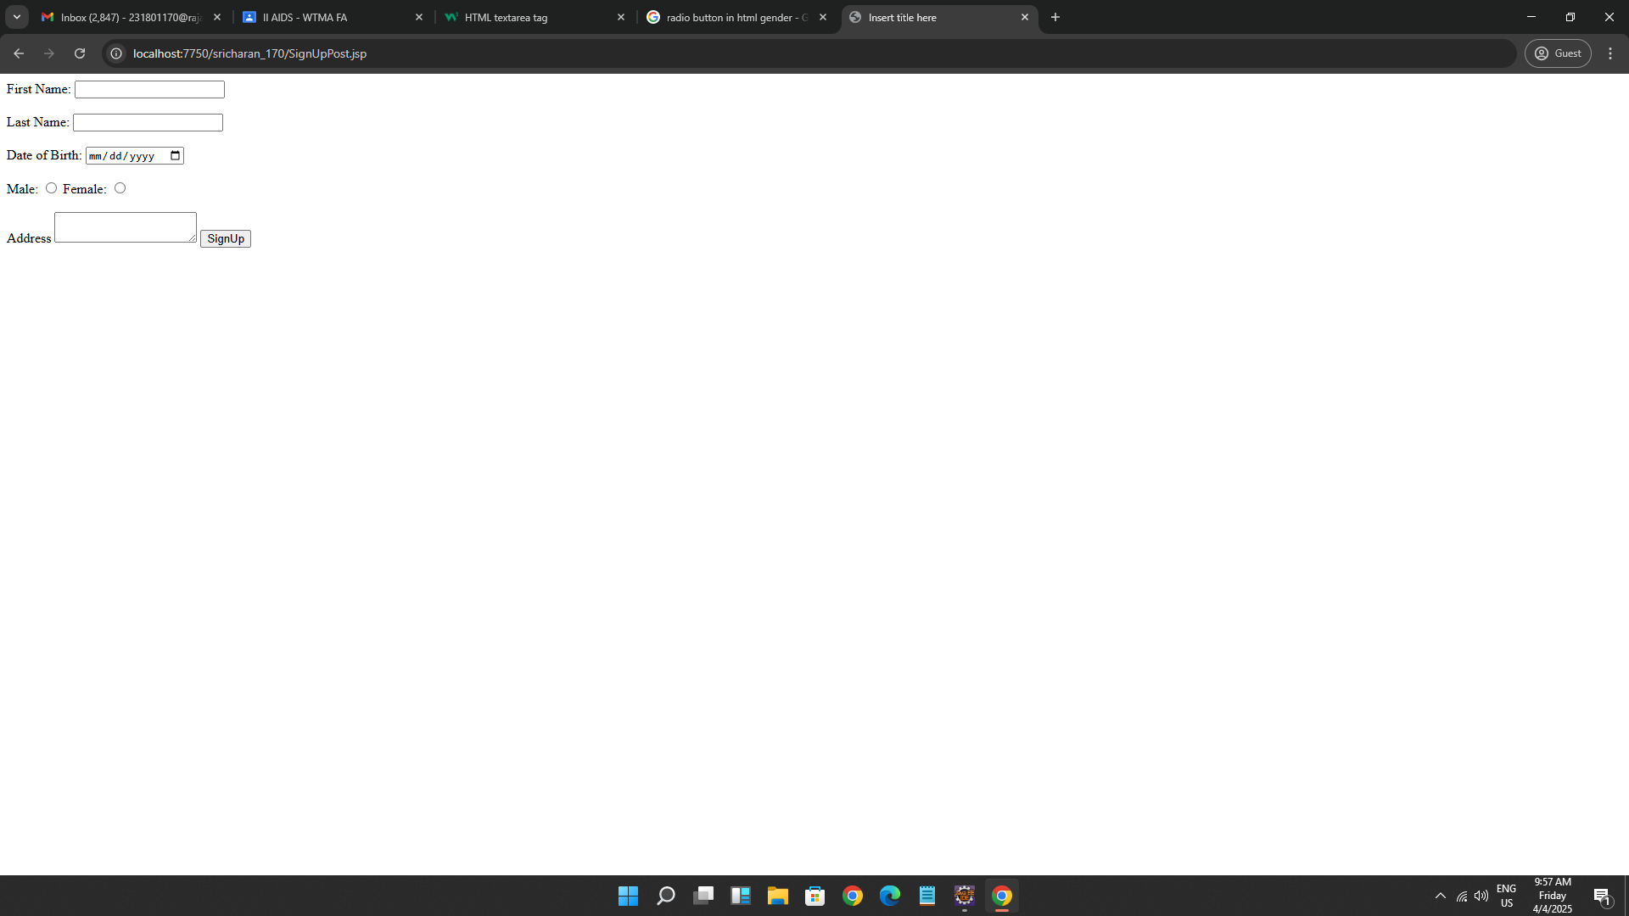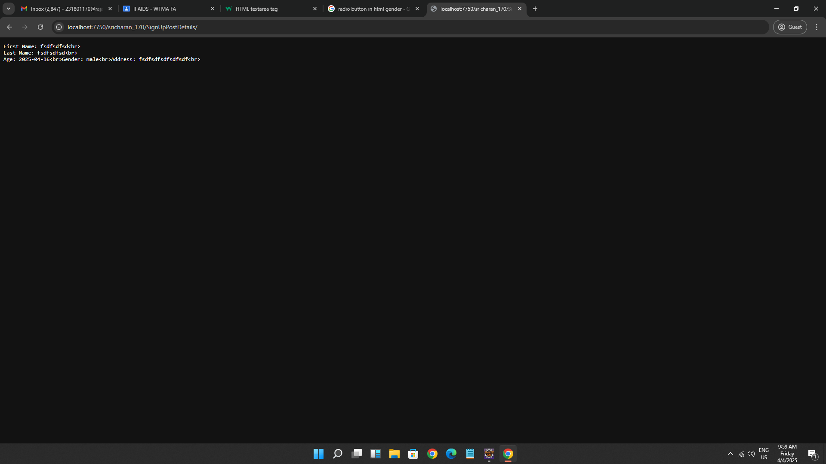

**RESULT :**

A servlet program to difference HttpGet and Post is successfully implemented.